**Department of Computing**

**CS250: Data Structures and Algorithms**

**Class: BEE-6AB**

# Lab 9: Quick Sort

**Date: 19th November, 2015**

**Time: 10am-1pm & 2pm-5pm**

# Instructor: Dr. Faisal Shafait

**Lab 9: Quick Sort**

**Introduction**

In this lab, you will implement quick sort.

**Objectives**

Objective of this lab is to implement Quick sort.

**Tools/Software Requirement**

Visual Studio C++

**Description**

You will implement the pseudo code given in the book "Introduction to Algorithms" by Cormen.

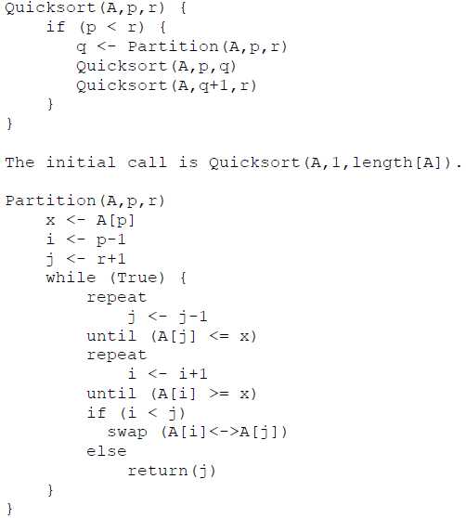

**Lab Tasks**

1. You will run the algorithm on arrays of random numbers in the range 1 to 100 with sizes 100, 1000, and 10000.

2. Compare how many partitions happened in each case.

3. Choose a different pivot value and see if number of partitions decreases. The new pivot value can be chosen as the median of the first, middle and last elements of the array.

**Deliverables**

Students are required to upload the lab on LMS before deadline.

**Note:** Use proper indentation and comments. Lack of comments and indentation will result in deduction of marks. You will submit your workingcodes in **word document** (do **NOT** take screenshot of code, just copy your code and paste it). The name of word document should follow this format. i.e. **YOUR_NAME_Lab#**